User Story-005

Testcase -001 : Verify My account button

Step1: Navigate to the URL of the opencart site 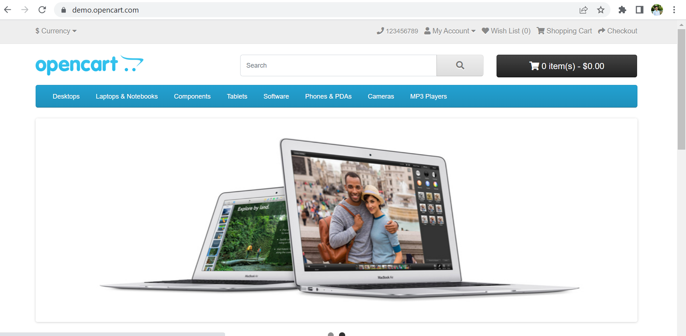

Step2: Click on the My account button Present on the Homepage and the User should be able to see the options for register and login

**All the steps are passed and testcase-001 executed successfully.**